PROJECT WITH ABTRACTS

GPS BASED TRANSPORT MANAGEMENT S/M

The Global System for Mobile Communications (GSM) has been a great success in providing both voice and low speed data services. The current evolution of GSM towards the third generation mobile communications system is attributed to its remarkable growth and also to the increasing demand for mobile data. The Enhanced Circuit Switched Data on GSM (ECSD) is one of the major evolutionary steps to serve real time high speed data services such as real time video and or file transfer. The ECSD enhances the bandwidth by combining several time slots and by utilizing efficient modulation and coding schemes.
Population inversion leads so many issues, one among that is accident. In this project we proposed a module to indicate accident to the transport owner/ manager. GPS receiver, GSM module and embedded kit are placed in vehicle whenever the vehicle met an accident or break down GSM module will send information to the owner and nearby police station and hospital. GPS receiver helps to give proper location.

RFID BASED INTELLIGENT TRAFFIC CONTROL

Abstract

Undoubtedly in the world of urbanization, time and efficiency are matter of priority. RFID (Radio Frequency Deification) emerges as one of the noteworthy converging technologies which improve standard of living, particularly the two abovementioned ones. While transportation, being mass transit or logistic, plays important part in the development of urbanization, RFID is now key catalyst in signify the merit of it. Thus, it is necessary to thoroughly study RFID technology for transportation advancement from initial deployment to each variety of its applications.
There are many RFID applications available in the market such as RFID contact less smart card commonly used by commuters or bus riders, Automatic Vehicle Identification (AVI) - an applied RFID technology, used in Electronic Toll Collection (ETC), Smart Parking, and Electronic Road Pricing (ERP). This paper has been carried out with a purpose to understand benefits of the RFID technology in other countries and to identify readiness of India in exploiting it. Traffic issues are doubled every year due to increase in population. RFID device based traffic signal simplifies this problem. RFID tags are placed in vehicles while enabling the signal the controller with RFID reader counts the vehicles in a particular direction, and takes the decision based that. If N - S/W (North to South and West) density is more then the corresponding signal (Green) is given priority to be activated first. Based on the traffic priority other signals are activated one by one.

RFID BASED FORM MANAGEMENT
Abstract
In a developed country, farmers have an access to advance technology for Radio Frequency Identification (RFID) farm management. Recently, RFID has become a globally recognized technology for animal identification to simplify farm activities such as automatic feeding. In a developing country, India, RFID is a cutting edge technology unknown to most farmers. Uneducated farm labors are often afraid of being replaced with technology while farm owners lack of interest in technology because of cheap labor cost (5 US dollars per day for the minimum wage).
RFID plays an important role in widening the digital gap in farm management because RFID investing pioneers will get the highest return and widen the gap much greater from an access to technology and information. The integration of greater information availability reduces feed waste and labor cost, improves animal health, and ease of animal management. Research survey indicates that low RFID usage in India is based primarily on four factors: RFID cost, standard, technology suitability, and lack of knowledge.
In India no poultry is automated. This project proposes an automated form. We have to maintain temperature in incubators of the form for maximum (hatching) outcome RFID temperature sensors are placed in every cell. Based on the report by the reader temperature is maintained and for feed management one more RFID tag is placed in every group and whenever the feed is less the reader alerts feed machine to supply.

RFID BASED TRAFFIC VOILATION CONTROL
Abstract
Traffic crime record is increasing every year. More no of accidents results the position to control so we are in violation .RFID/GSM is the powerful media for this traffic related issues. Undoubtedly in the world of urbanization, time and efficiency are matter of priority. RFID (Radio Frequency Deification) emerges as one of the noteworthy converging technologies which improve standard of living, particularly the two abovementioned ones. While transportation, being mass transit or logistic, plays important part in the development of urbanization, RFID is now key catalyst in signify the merit of it. Thus, it is necessary to thoroughly study RFID technology for transportation advancement from initial deployment to each variety of its applications.
There are many RFID applications available in the market such as RFID contact less smart card commonly used by commuters or bus riders, Automatic Vehicle Identification (AVI) - an applied RFID technology, used in Electronic Toll Collection (ETC), Smart Parking, and Electronic Road Pricing (ERP). This paper has been carried out with a purpose to understand benefits of the RFID technology in other countries and to identify readiness of India in exploiting it. In India Traffic issues are doubled every year due to increase in population. here we tried to control traffic crime rate by the latest RFID technology active in RFID is placed vehicle and full database of vehicle and owner is stored in that ( i.e. Insurance, license, RC book details owner name and address etc.)RFID reader is placed “N” no of matrix places and based on the received data traffic violation memo sheets is created .Finally the memo copy is sent to the concerned driver/owner.

Hospital Management

Abstract: Undoubtedly in the world of urbanization, time and efficiency are matter of priority. RFID (Radio Frequency Deification) emerges as one of the noteworthy converging technologies which improve standard of living, particularly the two abovementioned ones. We have implemented active radio frequency identification (RFID) asset management system in the hospital. The RFID system is used to track more than 2500 items within the hospital including infusion pumps, beds, and wheelchairs. The goal of this RFID project is to understand the limitations and benefits of the deployed RFID technology especially with regard to assessment of how the technology could be used to improve patient safety.
This project demonstrates that RFID systems technology enable the improvement of many processes in the hospital, thereby increasing patient safety and reducing operational costs. In this paper, we examine the RFID technology, including the rational for selecting the specific technology for this project, the installation process, and the benefits and limitations of the technology. Patient monitoring also done through RFID.Patient is identified by RFID Band. So doctors can easily find out perfect “case” for treatment also done by this.

RFID Based Asset owner change or sale management
Abstract

In this fast world civil court is facing so many cases on asset related issues. The latest wireless RFID (Radio frequency identification) technology provides perfect solution for these issues. There are many RFID applications available in the market such as RFID contact less smart card commonly used by commuters or bus riders, Automatic Vehicle Identification (AVI) - an applied RFID technology, used in Electronic Toll Collection (ETC), Smart Parking, and Electronic Road Pricing (ERP).
This paper has been carried out with a purpose to understand benefits of the RFID technology in other countries and to identify readiness of India in exploiting it. Some peoples are selling same asset to “n” no of peoples. In this paper we tried to solve this using RFID based Asset bonds (potent document). The full database will be stored in RFID tag. While inspecting that we can conclude about the asset. If any duplication or malpractice it may be conveyed to the parties.

RFID Reader enabled mobile for environment alert and mobile tracking

Abstract

The RFID (Radio Frequency identification) technology is most powerful identification tool for this commercial world. There are many RFID applications available in the market such as RFID contact less smart card commonly used by commuters or bus riders, Automatic Vehicle Identification (AVI) - an applied RFID technology, used in Electronic Toll Collection (ETC), Smart Parking, and Electronic Road Pricing (ERP).
Here we proposed a concept for mobile alert and tracking system using RFID technology. For RFID readers are integrated with Mobile phones and tags are placed in different locations. For environment alert the stored information is transmitted trough RFID tag. So, we can see the alert message on our phone, whenever we cross the area. The exact location information can be send through mobile towers to the tracking server. So ,from the tracking server we can collect the information of the phone.

RFID postal Service

Abstract

The RFID (Radio Frequency identification) technology is most powerful identification tool for this commercial world. There are many RFID applications available in the market such as RFID contact less smart card commonly used by commuters or bus riders, Automatic Vehicle Identification (AVI) - an applied RFID technology, used in Electronic Toll Collection (ETC), Smart Parking, and Electronic Road Pricing (ERP). In this we proposed an application of RFID in postal service.
Our postal service functioning on very old numbering technology without security. This project proposes an efficient and secured postal service though latest RFID technology. The conventional postal address is replaced with RFID based address tags in Home/office/Industry. The postal delivery may be controlled by authentication of Reader.

Design of DDC for Software Defined Radio in UHF Band

Abstract

Software defined radio is Reconfigurable modern radio. It may be adopted any frequency without any hardware mixer change. In conventional radio hardware mixers are used. So frequency range adaptation needs a mixer hardware modification and signal handling also varies. But here we use software mixers and down converters will give simplified design for a band of frequency range. This simplifies receiver circuitry. Here we proposed a design algorithm for DDC (Digital down Converter) for SDR receiver in UHF band. For simulation we have used powerful mathematical computation software Matlab and Virtual instrumentation software LabView for simulation

Design of 16 Band QPSK Receivers for SDR

Software defined radio is Reconfigurable modern radio. It may be adopted any frequency without any hardware mixer change. In conventional radio hardware Mixers are used. So frequency range adaptation needs a mixer hardware modification and signal handling also varies. But here we use software mixers and down converters will give simplified design for a band of frequency range. This simplifies receiver circuitry.
Here we Designed 16band QPSK receiver for SDR. For simulation we have used powerful mathematical computation software Matlab and Virtual instrumentation software Lab View.

SDR receiver for RFID Reader

Abstract

Software defined radio is Reconfigurable modern radio. It may be adopted any frequency without any hardware mixer change. In conventional radio hardware Mixers are used. So frequency range adaptation needs a mixer hardware modification and signal handling also varies. But here we use software mixers and down converters will give simplified design for a band of frequency range.
This simplifies receiver circuitry. RFID (Radio frequency identifying) is powerful identification tool. In this technology two destinations are there. One is Tag end and another side is Reader. Now a days RFID reader is designed using basic super heterodyne principal. But here we proposed an SDR based receiver architecture concept. It will better performance and efficiency. For simulation we have used powerful mathematical computation software Matlab and Virtual instrumentation software Lab View.

Prototype Design of smart antenna array using μcontroller

Abstract

Basically antenna is a passive element and it will not perform any intelligence. Smart antenna is a concept of making passive array in to intelligent one. Here the aim is to make an antenna to take decision to receive signal and reject. It will increase receiving efficiency and clears signal dead zones.
Here the concept is Array of antenna is placed towards different directions and the signal strength is analyzed and based on that decision is made. An antenna array with maximum strength for a particular user will be selected for communication. Here we use the concept called antenna array processor for decision making. In this concept we proposed μc based antenna array processor. The smart antennas are found great applications in mobile communication, wireless telephony, military communications, satellite communication and broadcasting.

Automatic Power Meter Reading System Using GSM Network

ABSTRACT

The development of GSM Automatic Power Meter Reading (GAPMR) System is presented in this paper. The GAPMR System is consists of GSM Digital Power Meters installed in every consumer unit and an Electricity e-Billing system at the energy provider side. The GSM Digital Power Meter (GPM) is a single phase IEC61036 standard compliance digital KWh power meter with embedded GSM modem which utilize the GSM network to send its power usage reading using Short Messaging System (SMS) back to the energy provider wirelessly. At the power provider side an e-Billing system is used to manage all received SMS meter reading, compute the billing cost, update the database, and to publish billing notification to its respective consumer through SMS, email, Web Portal and Printed postage mailing. A working prototype of the GAPMR system was build to demonstrate the effectiveness and efficiency of automatic meter reading, billing and notification through the use of GSM network.

Index Terms- Automatic Meter Reading, Digital Power Meter, GAPMR, Global System Mobile, Modem, Short Messaging System.

INTRODUCTION

Traditional meter reading for electricity consumption and billing is done by human operator from houses to houses and building to building. This requires huge number of labor operators and long working hour to achieve complete area data reading and billing. Human operator billing are prone to reading error as sometime the houses electric power meter is place in a location where it is not easily accessible. Labor billing job is sometime also restricted and slowed down by bad weather condition. Printed billing has the tendency of losing in the mail box. The increase development of residential housing and commercial building in the developing country such as for example, India requires more human operators and longer working hours to complete the meter reading task. This increases the energy provider operation costs for meter reading.

AMR System plays an important role to address the above mentioned problems. AMR is an effective mean of data collection that allow substantial saving through the reduction of meter re-read, greater data accuracy, allow frequent reading, improved billing and customer service, more timely energy profiles and consumption trends updates, and better deployment of human resource[1]. With the advent of digital technology, analogue electro-mechanical meter is continuously replaced by digital electronic meter. Digital energy meter offer greater convenience to implement and establish automatic meter offer greater convenience to implement and establish automatic meter reading system was a major challenge.

Various AMR methods and technologies using Power Line Carrier (PLC) communications, Supervisory Control and Data Acquisition (SCADA), telephone modem, Internet, Ethernet, Embedded RF Module, WiFi, Bluetooth and ZigBee were established and developed to provide and demonstrate the solution of efficiency, reliability and effectiveness of AMR. The above mention methods are either too expensive to implement and operate, require complex setup of infrastructure, short operating distant and still require field infrastructure, short operating distant and still require field intervention of human operators or prone to error and reliability issue due to noise in the transmission line or weather condition. With the rapid development of Global System Mobile (GSM) infrastructure and Information Communication Technology (ICT) in the past few decades has made wireless automatic meter reading system more reliable and possible.
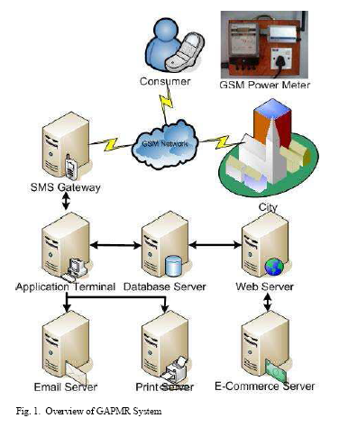
The GSM Automatic Power Meter Reading System (GAPMR) presented in this paper takes advantage of the available GSM infrastructure nationwide coverage in the country and the Short Messaging System (SMS) cell broadcasting feature to request and retrieve individual houses and building power consumption meter reading back to the energy provider wirelessly. The Store and forwarding features of SMS allow reliable meter reading delivery when GSM signal is affected by power weather condition. The stored SMS is archive in the mobile operator and can be later retrieve for billing verification purpose.
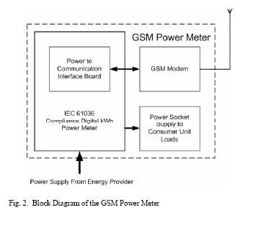

Study on Farm Information Acquisition by Using Wireless Remote Methods and Treatment Systems

Abstract

GSM is one of most important technology in wireless communication system, which contains three main services of short message, speech communication and data communication. Aiming at the feature of farm information acquisition of large quantity information, real-time and working in field, the paper combined the GSM module with farm information acquisition, and advanced a new farm information measurement system using wireless communication technology namely GSM technology.

The measurement system became more convenient after GSM technology putting to use. The system includes GPS receiver, moisture sensor, a device which was designed by programming of single chip computer to measure soil moisture and positioning, Zigbee device, GSM wireless communication module and a computer. The system could realize the function of transmitting the farm information to laboratory in the forms of GSM short message, and solved the problem of limitation of information storage and the inconvenience of carrying a data logger device to the farmland. Then based on the laboratory reports motor pumps, Urea suppliers and pest control units are activated automatically. Once the analyzed report is generated the control unit will work automatically.

ZigBee Device Access Control and Reliable Data Transmission in ZigBee Based Health Monitoring System

ABSTRACT: One user's health monitoring system has a few ZigBee devices to measure one user's physiological data. Even if there are a lot of ZigBee devices nearby, the communication should be accepted between only one user's ZigBee devices. So, the access control should be implemented because there can be a lot of ZigBee devices nearby. There is an access control in MAC layer but we design and implement it in application layer to handle conveniently. The physiological data must not be lost but a wireless communication such as zigbee can lose a data. So, this paper proposes the reliable data transmission not to lose a physiological data in zigbee based health monitoring system.
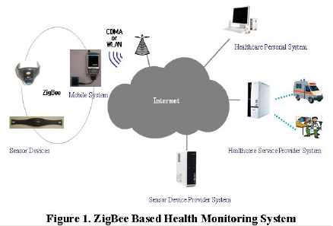
INTRODUCTION: Wireless technologies are used to rapidly exchange images, data, audio, and other information between remote locations. These technologies are currently being applied to improve healthcare around the world. For implementing a health monitoring system, first of all, devices that measure patient's physiological signal should be needed. The mobile system receives physiological data from wearable sensor devices as shown in figure 1. One user's health monitoring system has a few ZigBee devices to measure one user's physiological data. Even if there are a lot of ZigBee devices nearby, the communication should be accepted between only one user's ZigBee devices. So, the access control should be implemented because there can be a lot of ZigBee devices nearby. We propose the device access control mechanism. The physiological data must not be lost but a wireless communication such as zigbee can lose a data. So, this paper proposes the reliable data transmission not to lose a physiological data in zigbee based health monitoring system.

Design and Implementation of ZigBee based URC Applicable to Legacy Home appliances

Abstract: There are many various CE (Consumer Electronics) home appliances being controlled and managed with each different remote control unit based on IR (Infra-Red) signal in our home environments. A universal remote control (URC) unit is an integrated device for controlling these various devices (with a single one). To control them based on IR control signal, the URC unit has to have many pre-programmed control codes for controlling them because each home appliance is controlled with each its identical IR control profile. In case of appliances from different vendors, the IR profile for two different CE devices may be represented with different format even though the type of these appliances is same, such as television sets. In this paper, we propose a novel ZigBee based URC, called Z-URC in this paper, applicable to multiple legacy home appliances. The proposed Z-URC controls dynamically multiple legacy IR controllable digital CE appliances based on IEEE802.15.4, especially ZigBee protocol.

The proposed scheme consists of two main components; Z-URC(ZigBee based Universal Remote Control) and Z2IR(ZigBee to IR) conversion module. The one is an integrated remote control unit using ZigBee based wireless network technology, WPAN(wireless personal area network) and the other is a Z2IR(ZigBee to IR) conversion module which converts a control message transferred through the ZigBee network into an IR typed control signal. In the proposed scheme, the list of CE devices to be controlled by the proposed URC is dynamically reconfigured. It is based on his location as a consumer with the proposed Z-URC goes from a room to any other place in his house. The Z-URC gets some information for its controllable devices’ product identifier (ID) and vendor ID from WPAN (wireless personnel area network) based on ZigBee. A user may configure the two IDs for his CE appliances. Based on this feature, the module informs the Z-URC a target appliance’s information. And, we apply a novel mechanism to our proposed scheme to minimize power consumption of the Z2IR module, which is based on ZigBee devices’ ON/OFF control mechanism using multiple timers.

INTRODUCTION

Many various home appliances, most of which are controlled by IR(Infra-Red)[1][2] signal based remote control unit, are used in today’s digital home environments. A universal remote control (URC)[3] unit is an integrated device for controlling many different consumer electronics (CE) home appliances with a single one. To control these various CE devices based on IR control signal, the URC unit has to have many pre-programmed control codes for controlling them because they are controlled with many different types of IR profile stated with leader code, control code, carrier frequency, duty cycle, duration and so forth. In addition to this difficulty, the IR based URC can control any devices under the only condition of line of sight.
In this paper, we propose a dynamic control scheme for controlling and managing IR controllable multiple legacy CE appliances, which is based on IEEE802.15.4 [4]-[6], especially ZigBee [7] protocol. The proposed scheme uses two types of main components. One is a URC unit using ZigBee based wireless network technology, WPAN (wireless personal area network)[4][7][8]. Another is a Z2IR (ZigBee to IR) conversion module which converts a control message transferred through the ZigBee network into an IR typed control signal. The ZigBee based URC, called as ZURC (ZigBee based universal remote control), operates as a ZigBee coordinator in our proposed scheme, while Z2IR modules, which are attached to target appliances, operate as ZigBee devices. In the proposed scheme, the list of CE devices to be controlled by the Z-URC is dynamically reconfigured. It is based on his location as a consumer with the Z-URC goes from a room to any other place in his house. That is to say, the Z-URC shows a list of CE devices to be controllable with it.
The proposed Z2IR contains only a specific IR control code for its target appliance, which codes is initialized and installed to the Z2IR module during setup procedure. A user may configure its product and vendor identifiers (IDs) of the home appliances to be controlled by the IR control signal from the module. Based on this feature, the module informs Z-URC target appliance’s information and takes its IR control codes for its target appliance through ZigBee WPAN. And, we apply a novel mechanism to minimize power consumption of the Z2IR module, which is based on ON/OFF mechanism of ZigBee devices using multiple timers.
This paper show the implementation of the proposed ZigBee based URC mechanism applicable to legacy IR controllable CE devices. The remainder of this paper is organized as follows. We first describe and review ‘IR remote control’ being used in most CE appliances to control them and introduce URC to control many home appliances with a remote control unit. Next, we propose a ZigBee based URC including system configuration and its algorithm to control dynamically multiple IR controllable CE appliances.

Model Diagram:

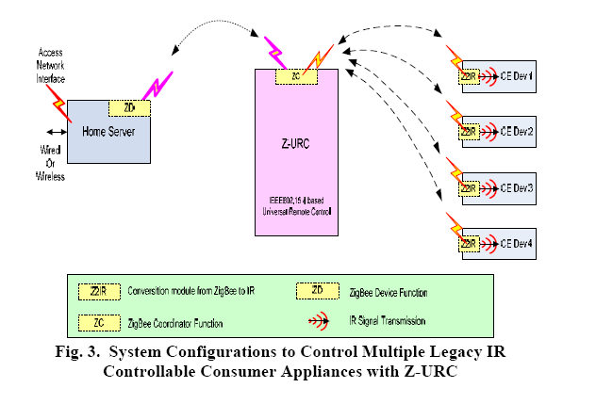

Using ZigBee Wireless Network to Transfer
Water-Sludge Interface Data

ABSTRACT: This paper points out the disadvantages of formerly proposed data transfer method used in the monitoring system of WTP. A data transmit solution which uses ZigBee wireless communication standard is proposed. The technical characteristic of ZigBee technology is introduced. The hardware and software design are presented. The paper Emphasizes on the implementation of ZigBee protocol and data communication flow. The experimental and application results have shown that ZigBee technology is suitable for the wireless data transmission in the environment of WTP. The reliable transmission of data to the control center of WTP has been realized in some in-situ applications.

INTRODUCTION: The data of water-sludge interface is a crucial parameter to the performance of wastewater treatment in the WTP. To ensure the drained water's quality and the backflow sludge's density, we need to examine the data using a water-sludge interface gauge and transmit to control center on-line. The interface gauge circles around the center of sedimentation tank with the mud scraper, so the wired date transmission is very difficult. To solve these problems, this paper proposes ZigBee wireless communication protocol to transfer water-sludge interface data. The whole system is designed of a star topology network and worked at a wake-up on-demand communication mode to reduce the power consumption. It contains four sensor nodes (RFD devices) and one coordinator (FFD device). The sensor nodes are powered by battery. The data collecting is continuous, and the nodes' power consumption should be very low. ZigBee technology meets this need. The coordinator node transmits data to a PC through RS-485. The transfer distance of ZigBee wireless network is between 70-300m, and it is enough to the application requirement. The transmission system is composed of low power consumption MCU and RF transceiver.
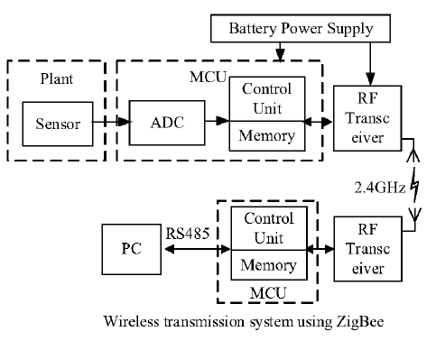

RFID BASED ACCIDENT ALERT AND TRANSPORT MANAGEMENT SYSTEM

ABSTRACT: Undoubtedly in the world of urbanization, time and efficiency are matter of priority. RFID (Radio Frequency Deification) emerges as one of the noteworthy converging technologies which improve standard of living, particularly the two abovementioned ones. While transportation, being mass transit or logistic, plays important part in the development of urbanization, RFID is now key catalyst in signify the merit of it. Thus, it is necessary to thoroughly study RFID technology for transportation advancement from initial deployment to each variety of its applications. There are many RFID applications available in the market such as RFID contact less smart card commonly used by commuters or bus riders, Automatic Vehicle Identification (AVI) - an applied RFID technology, used in Electronic Toll Collection (ETC), Smart Parking, and Electronic Road Pricing (ERP). This paper has been carried out with a purpose to understand benefits of the RFID technology in other countries and to identify readiness of India in exploiting it.
The Global System for Mobile Communications (GSM) has been a great success in providing both voice and low speed data services. The current evolution of GSM towards the third generation mobile communications system is attributed to its remarkable growth and also to the increasing demand for mobile data. The Enhanced Circuit Switched Data on GSM (ECSD) is one of the major evolutionary steps to serve real time high speed data services such as real time video and or file transfer.
Population inversion leads so many issues, one among that is accident. In this project we proposed a module to indicate accident to the transport owner/ manager and alert to the police and hospital. RFID reader, Vibration Sensors, GSM module and embedded kit are placed in vehicle and RFID tags are plugged in the road to indicate area information. Whenever the vehicle meets an accident or break down GSM module will send information to the owner and nearby police station and hospital. RFID reader helps to give proper location and we can also display environment alert information.

Key Words: RFID, GSM and RFID Reader

RFID
RFID
RFID

RFID Tag
RFID Tag
RFID Tag
RFID Tag
RFID Reader
GSM Module
Vibration Sensors
Embedded Module
Mobile
(Police)
Mobile
(Hospital)
Mobile
(Owner)

Some Special Titles
- SDR based Digital Satellite transponder using Matlab/Labview
- SDR based DTH receiver
- SDR based FM receiver realized using Matlab/Labview
- SDR based telegraph receiver using Matlab/Labview
- SDR based Bluetooth receiver using Matlab/Labview
- SDR based WiFi device using Matlab/Labview
- SDR based ZigBEE device using Matlab/Labview
- Design FM section for TV receiver using SDR architecture
- Design of Smart antenna for TV receiver
- Smart receiving antenna algorithm for ZigBee device
- Smart antenna for GPS receiver.
- Networked wireless meter reading using ZigBee
- ZigB surveillance robot
- RFID enabled robots for hospital management.
- Cab monitoring system enabled through RFID and Webcam
- Automatic railway gate control using RFID
- An Integrated ZigBee Automation System:An Energy Saving Solution
- Smart parking system using RFID
- Intelligent traffic controller using Image processing
- Coin counting using image processing for Tirupathi temple
- RFID and GSM based library information and alert system.
- RFID based students attendance and movement management
- Front panel display for leg operated mp4 player for physically challenged people
- RFID Keeper: An RFID Data Access Control Mechanism
- An Overview of RFID System Interfaces and Reader Protocols

